**Database Study**

**Project Aims and Objectives**

The project objectives are:

* To reduce the paper work due to the manual systems currently in place no longer meet the needs of the organization
* To record every dog in the database, this would include breed, name, age and gender
* To record every adoption
* To ensure that the necessary information will be available to provide proper care to their animals
* To keep track of new arrivals
* To enable fast access to contact details of members and staff
* To design a user friendly interface
* To maximize efficiency

**Background of Project**

A Dog Shelter Management System is an application which is suitable to use by a small and medium size shelter. It is used by staff members to manage the shelter using a computerized system. The system was developed and designed to help the staff record every dog adoption. The system includes Dogs, Adopters, Volunteers and Staff sections. Staff can register or edit the member or dog in the system.

**My Role**

I have been hired by the Dogs Aid Animal Sanctuary to create a database that will enable them to manage their business operations more effectively. The shelter rescues and takes in dogs in need and provides a means for them to find a loving home. I have been asked to meet with the owner of the shelter to get as much information as possible. The staff is responsible for managing and keeping track of all dogs, members and adoptions. The system used now has been a non-electronic, manual system which stored the member’s details and stored the details of the dogs separately.

**Requirements Gathering**

* To be able to track information related to the dogs
* To be able to search data related to prior history and delivery of the dog
* To be able to track information related to adopters (members)
* To be able to see the contact details of members
* To be able to search for the contact details of staff members
* To be able to search if the dog is vaccinated
* To be able to see if the dog has been spayed or neutered
* To be able to keep track of recurring volunteers

**Process Flow**

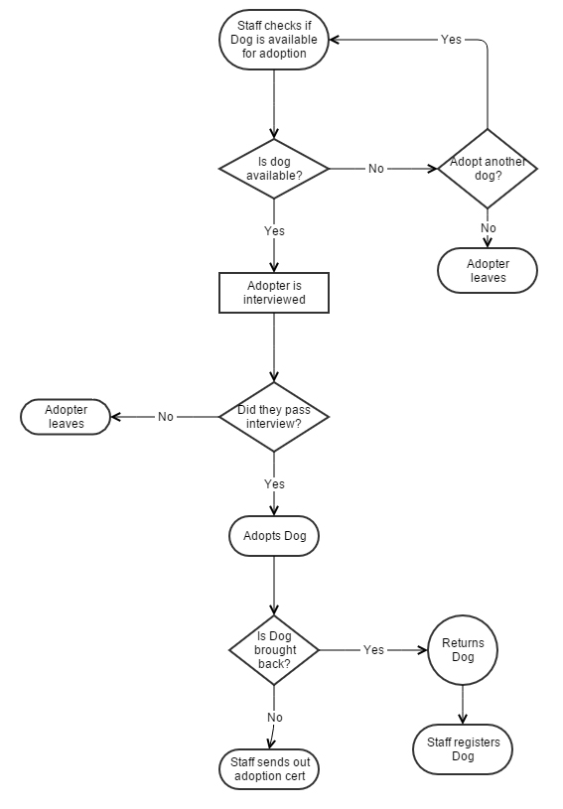

**Business Rules**

* An adopter may adopt up one dog, but a dog can be adopted by many adopters
* A dog can only have one sleeping area
* A dog can be adopted by members only
* Members must give the shelter their personal information
* The shelter will have a background check on adopters after they adopt
* The shelter needs information about the dogs that come in
* Volunteers can only look after the dogs they are assigned

**Conceptual Design**

**Step 1 – Identify Main Entity Types**

Dogs

Adopters

Volunteers

Staff

**Step 2 – Find Relationships**

|  |  |  |  |  |
| --- | --- | --- | --- | --- |
|  | Dogs | Adopters | Volunteers | Staff |
| Dog |  | Is adopted by | Is looked after by | Is taken in by |
| Adopter | Adopts |  |  | Is served by |
| Volunteer | Looks after |  |  | Is recruited by |
| Staff | Takes in | Serves | Recruits |  |

**Step 3 – Rough ERD**

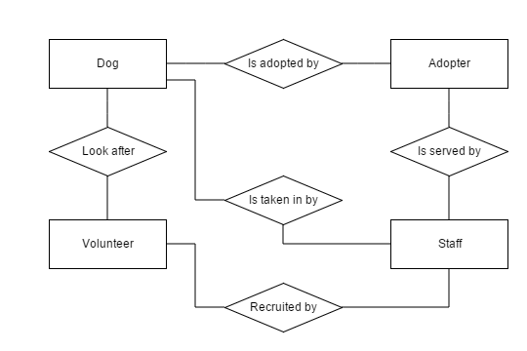

**Step 4 – Fill in Cardinality**

**Step 5 – Determine Primary Keys**

**ENTITY PRIMARY KEY**

Dogs DogID

Adopters AdID

Volunteers VolID

Staff StaffID

**Step 6 – ERD with Primary Keys**

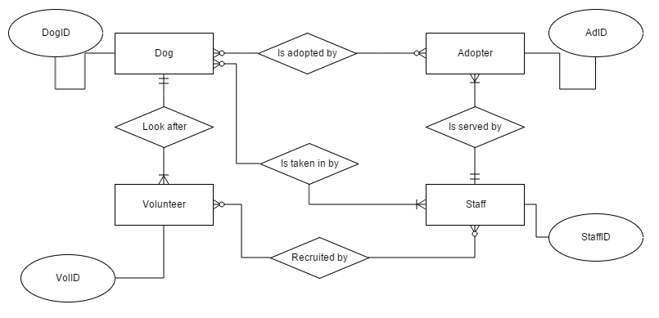

**Step 7 – Identify Attributes**

Dogs have DogID, DogName, DogBreed, DogGender, DogAge, DogVac, DogSpay_Neut

Adopters have AdID, AdName, AdAddress, AdPhone, AdEmail

Volunteers have VolID, VolName, VolAddress, VolPhone, VolEmail

Staff have StaffID, StaffName, StaffAddress, StaffPhone, StaffEmail

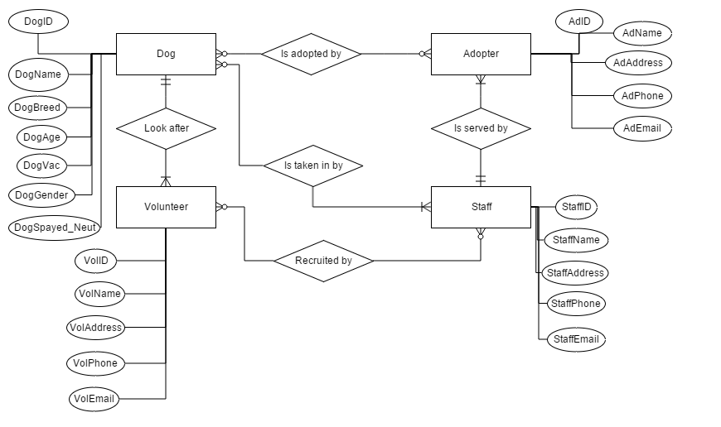

**Step 8 – Map Attributes**

|  |  |
| --- | --- |
| **Entity** | **Attribute** |
| Dog | DogID, DogName, DogBreed, DogAge, DogGender, DogVac, DogSpayed_Neut |
| Adopters | AdID, AdName, AdAddress, AdPhone, AdEmail |
| Volunteers | VolID, VolName, VolAddress, VolPhone, VolEmail |
| Staff | StaffID, StaffName, StaffAddress, StaffPhone, StaffEmail |